Legal Definition of Insanity
Research & Preview Questions:
- In your own words, what is the definition of “Criminal insanity”?

- In what type of cases is the court most likely to rule in favor of insanity?

- Why do you think the insanity plea is so rarely successful in criminal cases?

Research Subjects: Research the lives of serial killers and then pick one. Examples to choose from: David Berkowitz, Edmund Kemper, Larry Bittaker and Roy Norris, Ian Brady and Myra Hindley, Kenneth Bianchi and Angelo Buono (The Hillside Stranglers), Dennis Rader (the BTK Killer), Donald Henry Gaskins, Peter Manuel, Arthur Shawcross, Richard Ramirez, Jeffrey Dahmer, Ted Bundy, Charles Ng and Leonard Lake, John Wayne Gacy, Andrei Chikatilo, Tommy Lynn Sells, Gary Ridgway, Pedro Rodrigues Filho, Daniel Camargo Barbosa, Dr. Harold Shipman, Pedro Alonso Lopez.
After researching the serial killer and answering the above questions, you will be creating a criminal profile that includes and thoroughly explains each of the following information:
- Birth Date
- Death (or if still incarcerated)
- Nickname
- Family/Environmental Background
- Personality Profile
- Describe what they did
- Stated Motives behind the murders
- How were they caught
- Do they fit your definition of criminally insane? Explain your answer thoroughly.
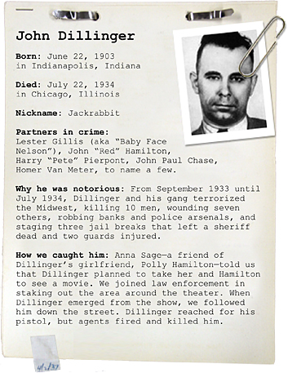
- Include on the back whether or not your serial killer would be considered criminally insane in YOUR court of law. Make sure you support your opinion with evidence and DEFINE what is criminally insane. Use the questions from the packet to help you.
HAVE FUN WITH THIS AND BE CREATIVE!
Questions worth: 15 points
Criminal Profile: 35 points

