Getting to Know You And Your Brain!!!
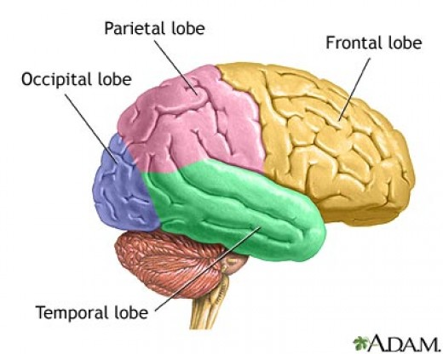
FRONTAL LOBE: controls emotions, movment and creativity
Emotions…List 3 things you love
1.__________________
2._________________
3.__________________
Movement…List 3 things you enjoy to do
1.__________________
2.__________________
3.__________________
Creativity… List 3ways you are creative
1.__________________
2.__________________
3.__________________
OCCIPITAL LOBE: responsible for sight
What would you like to see in your future? (Goals)
1.________________
2.________________
3.________________
TEMPORAL LOBE: responsible for hearing and language
Hearing: Favorite Music_________________________________________________________
Language: Favorite Quote________________________________________________________
PARIETAL LOBE: controls the five senses, and the perception of these senses and the world around us.
Pereption: What is your favorite part about OEHS?

