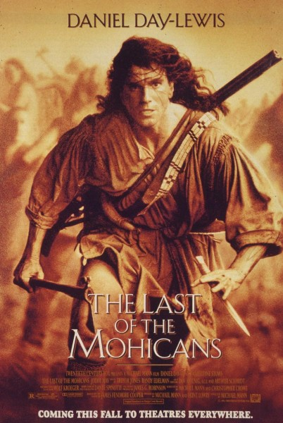
WANT EXTRA CREDIT!?

Come to Room 260 after school and watch a movie for
Modern World History!

Movie: Last of the Mohicans
When: Tuesday, December 10th
2:30pm-5:00p
Dear Parents/ Guardians of Modern World History Students,
For Modern World History your students have the option to watch as extra credit, The Last of the Mohicans, a film which depicts the French and Indian War from the perspective of a colonial man who was raised by a tribe called the Mohicans. The reason that we would like to show this film is because we believe that it accurately portrays life in 1600s British America as well as depicting what battles were like during this era.
This movie is rate R for violence, thus the purpose of this letter. We understand the issue of showing rate R movies in a high school class, however we would not have chosen this movie if we did not truly believe that it had historical merit and would enhance your student’s understanding of the French and Indian War.
Below is where you can sign allowing your student to be able to view this movie after school from 2:30pm-5:00pm, Tuesday, December 10th. Please detach the bottom and have your student return the slip to the teachers who will be signing in students in the auditorium on the day of the film. Also, due to this being an after school event, please make the necessary arrangements with your student for pick-up as the activity buses will not be available.
If you do not wish your student to view this film, please disregard this parent slip. Your student will not lose points or be reprimanded in any way. This film is merely extra credit and is meant to enhance their learning.
Please do not hesitate to e-mail me with any issues or concerns.
Thank you,
Sean Kelleher
skelleher@oswego308.org

- - - - - - - - - - - - - - - - - - - - - - - - - - - - - - - - - - - - - - - - - - - - - - - - - - - - - - - - - - - - - - - - - - - - - - - - - - - - - -

- Yes, my student, ___________________________________________, has permission to watch this movie.

Parent/Guardian Name (please print): _____________________________________________________

Parent/ Guardian Signature: _____________________________________________________________

