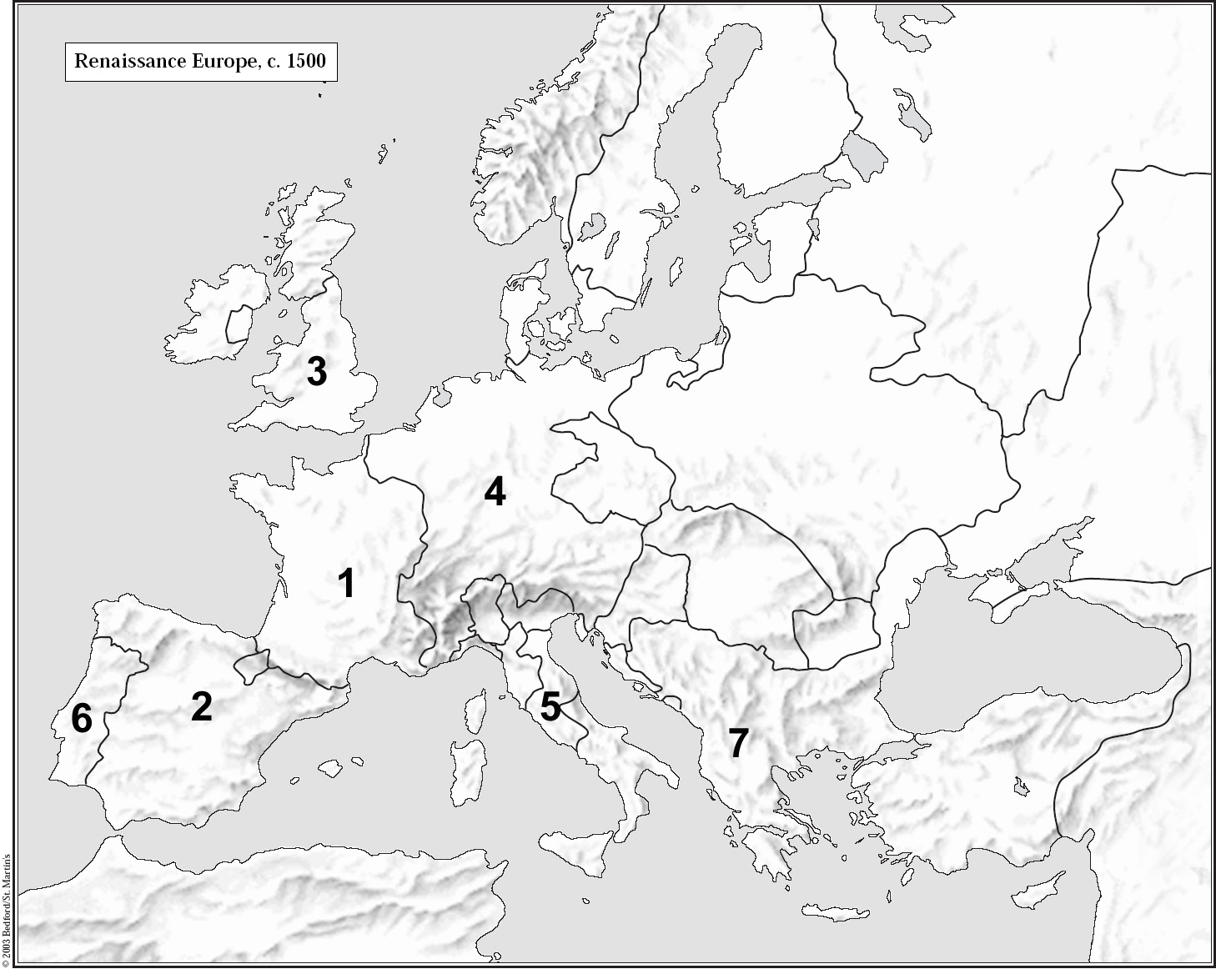**Europe, 1500 AD**

**Countries/ States**

●Portugal ●Spain ●France ●England ●Ireland ●Holy Roman Empire ●Poland ●Papal States ●Kingdom of Naples ●Swiss Confederation ●Venetian Republic ●Norway- Denmark ●Sweden ●Lithuania ●Hungary ●Ottoman Empire ●Kingdom of Sicily ●Corsica ●Sardinia ●Flanders ●Avignon ●Austria ●Scotland

**Geographic Masses**

●Mediterranean Sea ●Atlantic Ocean ●North Sea ●Baltic Sea ●Adriatic Sea

**Cities**

●London ●Wittenberg ●Mainz ●Madrid ●Rome ●Naples ●Milan ●Trent ●Geneva ●Prague ●Florence ●Mantua ●Augsburg ●Worms ●Paris ●Nantes