Learning Objective One: Identify the structure and functions of the human brain.
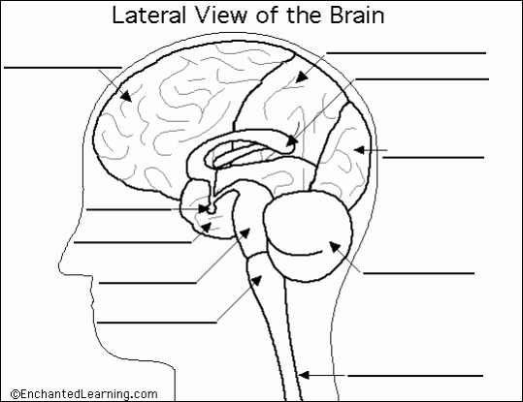
- Color each of the 4 different lobes of the brain different colors: The Cerebral Cortex is made up of the: Parietal lobe, Temporal lobe, Frontal lobe and Occipital Lobe. Label each of these brain parts.
- Continue to label the following parts of the brain, drawing lines to where they are exactly:

Frontal Lobe of Cerebrum
Spinal Cord
Parietal Lobe of Cerebrum
Corpus Callosum
Occipital Lobe of Cerebrum
Medulla Oblongata
pons
Pituitary Gland
Temporal Lobe of Cerebrum

- By each label, briefly describe the functions each part of the brain is responsible for.

Learning Objective Two: Identify parts of the nervous system.

