Absolutism Test Study Guide

Complete on a separate sheet of paper and then staple to this sheet.

Define
- Charles I-
- English Civil War-
- Oliver Cromwell-
- Glorious Revolution-
- Habeas corpus
- Restoration
- Cabinet
- Constitutional Monarchy
- Frederick the Great-
- Seven Year’s War-
- Ivan the Terrible-
- Boyar-
- Guy Fawkes

- Divine Right-
- Spanish Armada-
- Sun King-
- Versailles-
- Edict of Nantes-
- Thirty Years War-
- Maria Theresa-
- Westernization-
- Absolute Monarch-
- Jean Baptiste Colbert-
- Intendant-
- Cardinal Richelieu-
- Louis XIV- Boyar-
- Peter the Great-
- Despot

What led to the Age of Absolutism?
What did absolute rulers attempt to do with their power?
What caused an increase in the power of Philip II and Spain?
Which Spanish ruler attempted to defend Catholicism against the Muslims and Protestants?
How were the English able to defeat the Spanish Armada?
What happened to Spanish power by the end of Philip’s reign?
What was the purpose of issuing the Edict of Nantes?
Who was the Sun King?
Why did Louis XIV have nobles live in Versailles, away from cities?
Describe Louis XIV’s legacy.
What was the most important result of the Thirty Years’ War?
Why did strong states form more slowly in Central Europe than Western Europe?
What were the accomplishments of Maria Theresa?
What was the land-owning nobility in Russia called?
Describe the relationship between Ivan the Terrible and the boyars.
Why was the culture of Russia very different than that of the rest of Europe?
In what ways did Peter the Great want to reform Russia?
Describe Catherine the Great’s reign.
Why did the English Civil War occur?
Which two groups fought in the English Civil War?
What is a constitutional monarchy?
Describe the reign of the following English rulers: Elizabeth I, James I, Charles I, Oliver Cromwell, Charles II, James II
What is Guy Fawkes Day and what occurs?
Why is Guy Fawkes famous?
What are three theories historians have about the “Man in the Iron Mask?”
Who is Eustache Dauger? What significance does he hold to the “Man in the Iron Mask?”
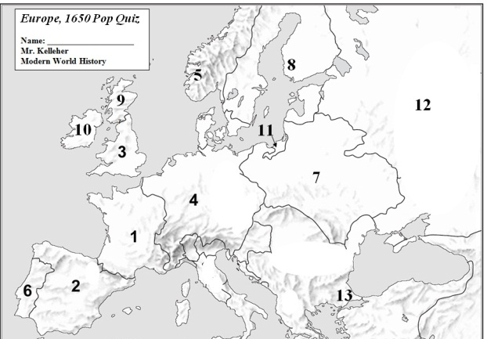
Map: Study your 1650 map.

Short Answer: Choose one
absolute monarch. Explain
how that monarch gained, used
and justified their power.

